Home page
- Add the hero image (also there is attribute called about image, what I will use???)
- Also the bio, there is bio and bio_en (what to use in English??)
- What is the provided image and where its endpoint
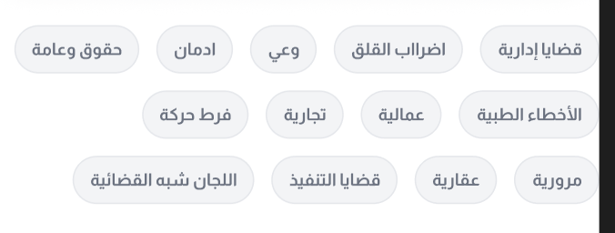
- There is no data in the reels
- There is no data for the clients review

